BLIND AND LOW VISION (BLV)

TENNIS CLASSES

SEPTEMBER 2026

FREE REGISTRATION - RACKETS PROVIDED
COME TO ONE CLASS OR BOTH CLASSES

WHERE:
Columbia Heights Community Center, 1480 Girard Street, NW, DC 20009

WHEN:
Saturday September 19 10:00am to 12:30pm*
Saturday September 26 11:00am to 12:30pm

*There will be a 1-hour train the trainer (how to teach BLV Tennis) at 10:00AM the first Saturday, September 19. All participants who want to learn or play may come at 11:00AM that day.

TO REGISTER AS A PARTICIPANT - OR - AS AN INTERESTED PARTY
https://form.jotform.com/261815928546165

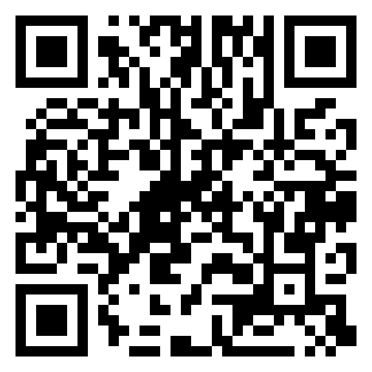

FOR INCLEMENT WEATHER you will be contacted by email in advance
FOR MORE INFORMATION email adaptive@tennisallianceaac.org
